# Read Me

Catalogue

1.SceneBuilder 1

1.3After successful entry, select Apply>OK 2

2. JavaFX 3

2.1Project Structure 3

2.1.2 Click +，choose JARs or Directories... 3

2.1.4 After completion, check and click Apply>OK 4

2.1.6 Click on the+in the middle bar and select Java 5

2.1.8 Click Apply>OK to save 5

3.Test Junit 8

4.JDK 20

1. IntelliJ IDEA

**SceneBuilder**

1.1 Download scene builder

Download address：

<https://gluonhq.com/products/scene-builder/#download>

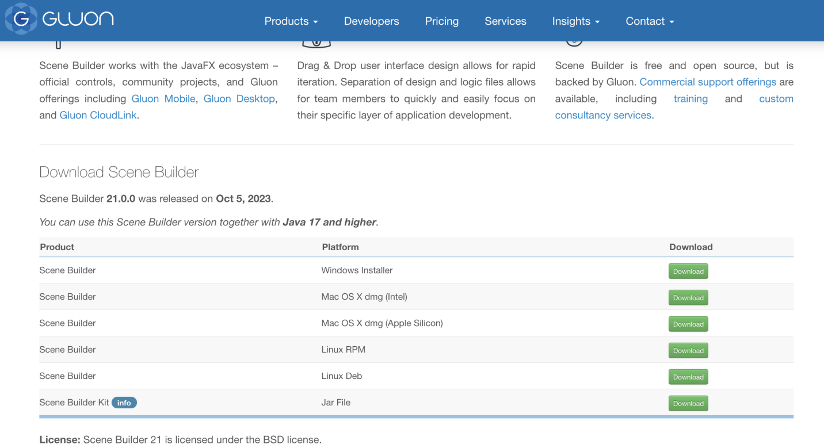

1.2 Configure in IntelliJ IDEA

IntelliJ IDEA>Settings>Languages&Frameworks>JavaFX, and then

select the path: Scene Builder>Contents>SceneBuilder. exe file

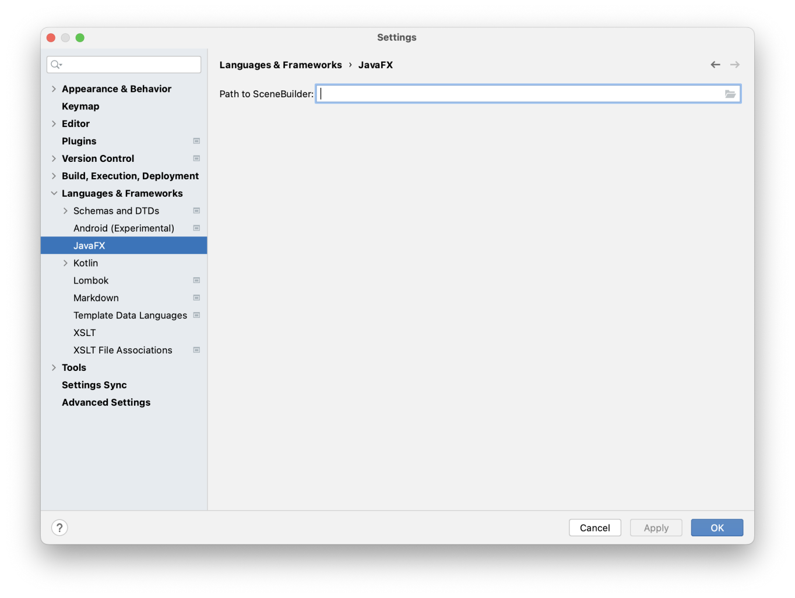

1.3 After successful entry, select Apply>OK

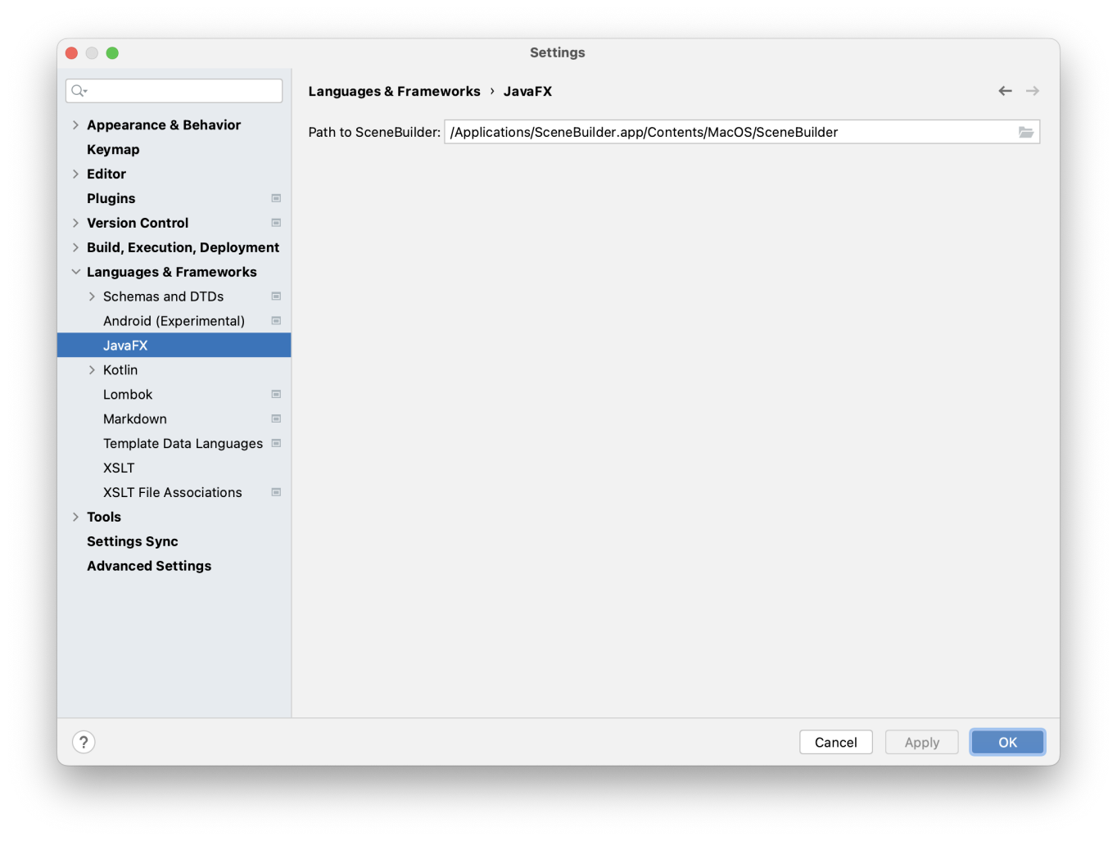

**JavaFX**

[JavaFX - Gluon (gluonhq.com)](https://gluonhq.com/products/javafx/)

2.1Project Structure

Open File>Project Structure>Modules>dependencies，confirm that the JAVA environment version is SDK 20

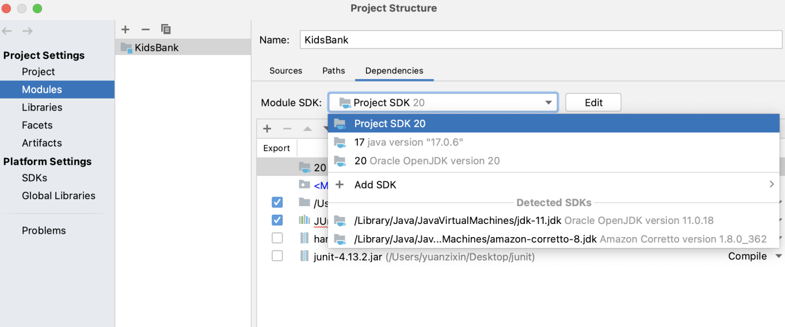

2.1.2 Click +，choose JARs or Directories...

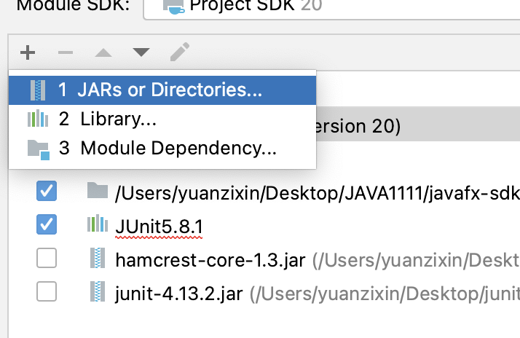

2.1.3 Choose your own download address/javafx-sdk-22/lib，click open

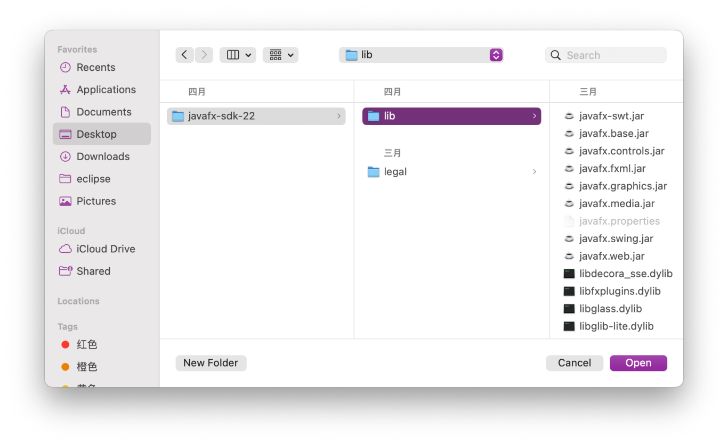

2.1.4 After completion, check and click Apply>OK

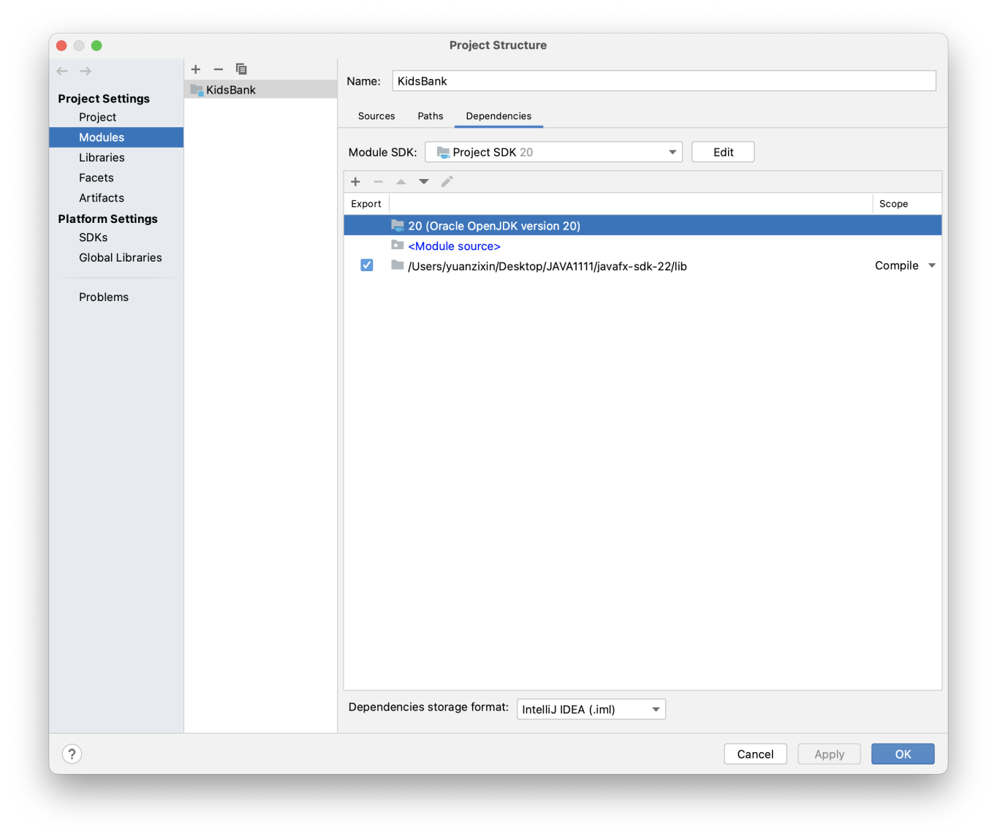

2.1.5 Continue back to the previous interface and enter File>Project Structure>Global Libraries

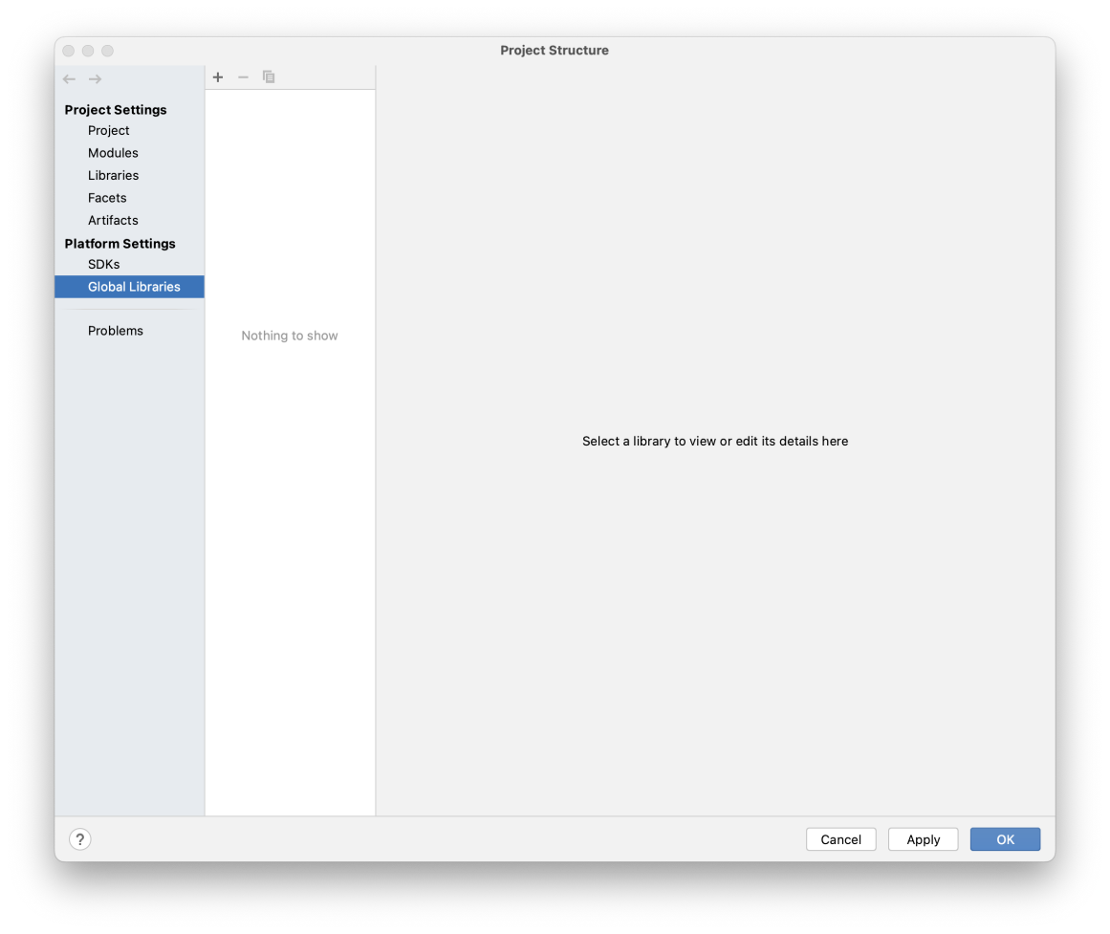

2.1.6 Click on the+in the middle bar and select Java

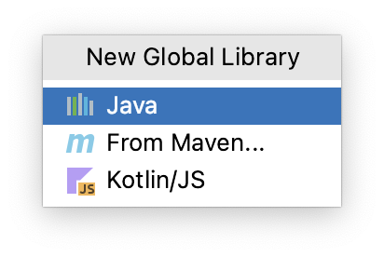

2.1.7 Select the address in the pop-up window:

Your own address/Javafx sdk-22/lib (as shown in the figure below), and click Open

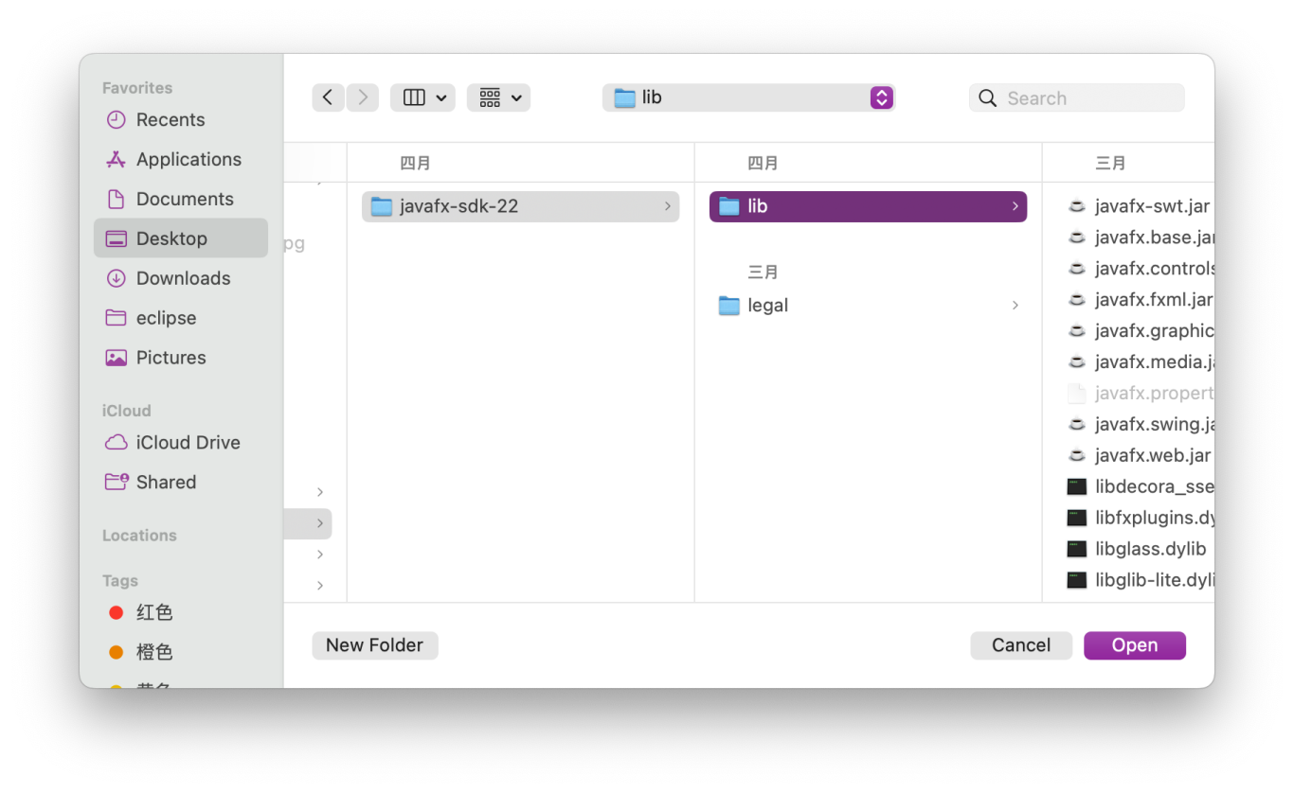

2.1.8 Click Apply>OK to save

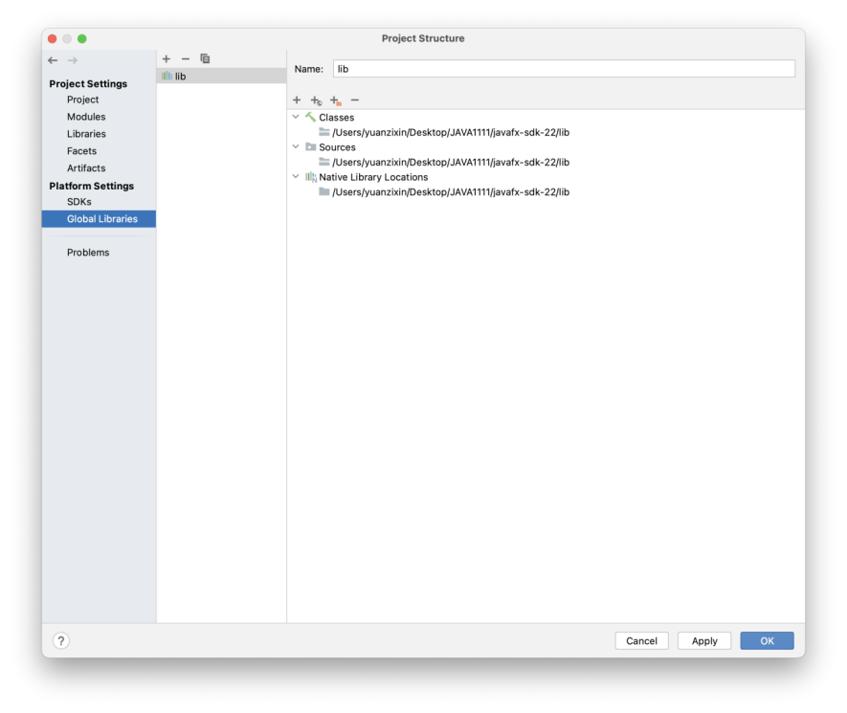

2.2 Set Run page

2.2.1 Go to Run>Edit Configuration>Environment variables to edit the address

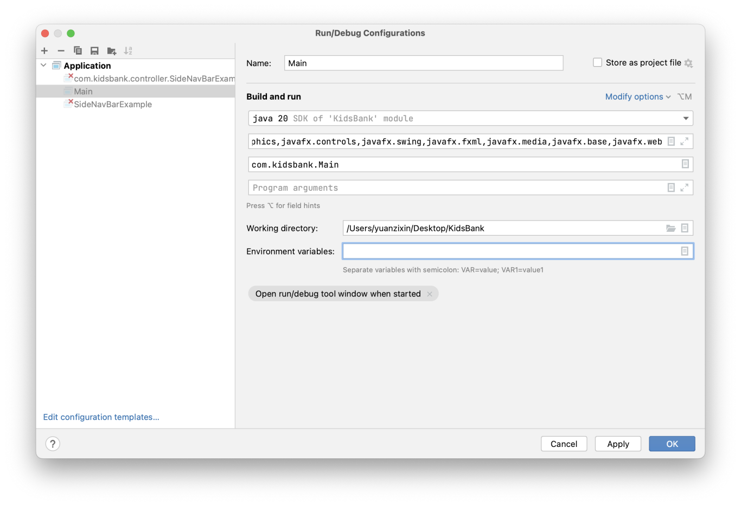

2.2.3 Add environment variables:

Click the + button, add a new environment variable, and then click OK to save.

Name ： JAVAFX21

Value: Your own download address/javafx-sdk-22/lib (Enter the path to the JavaFX SDK)

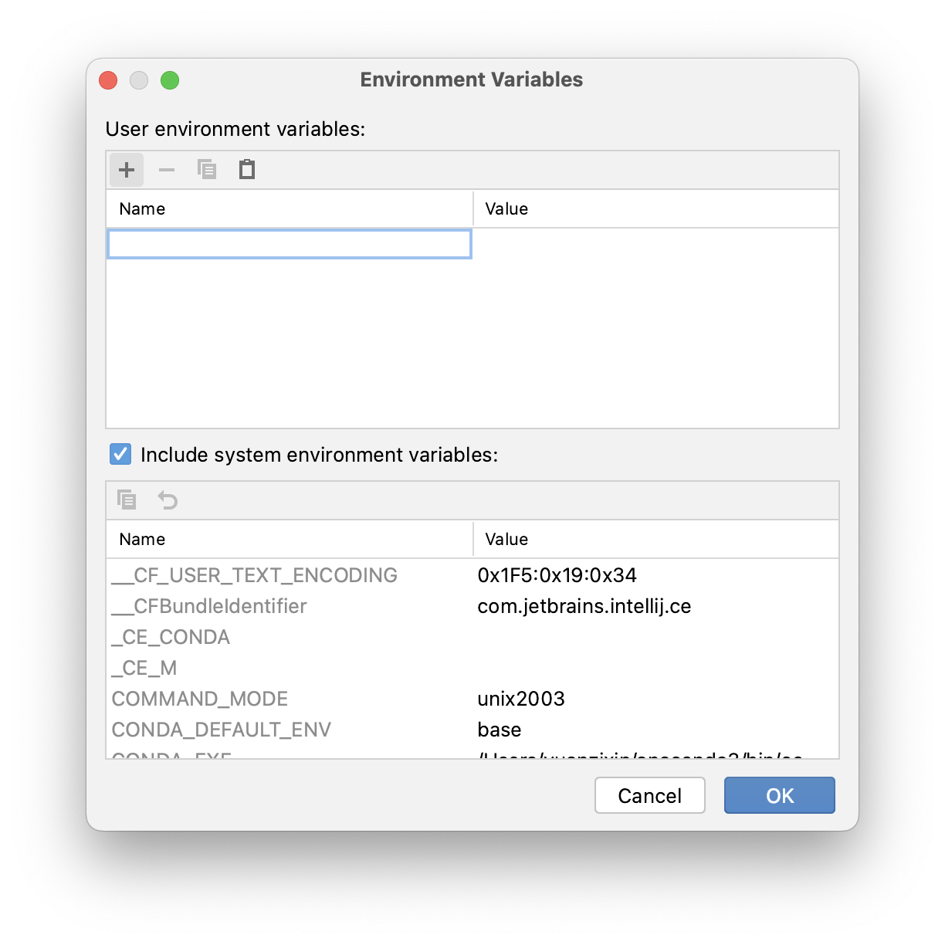

2.2.2 Confirm the content of the second line of build and run as follows. If it is different, correct it and click Apply>OK

--module-path $JAVAFX21$ --add-modules

javafx.graphics,javafx.controls,javafx.swing,javafx.fxml,javafx.media,javafx.base,javafx.web

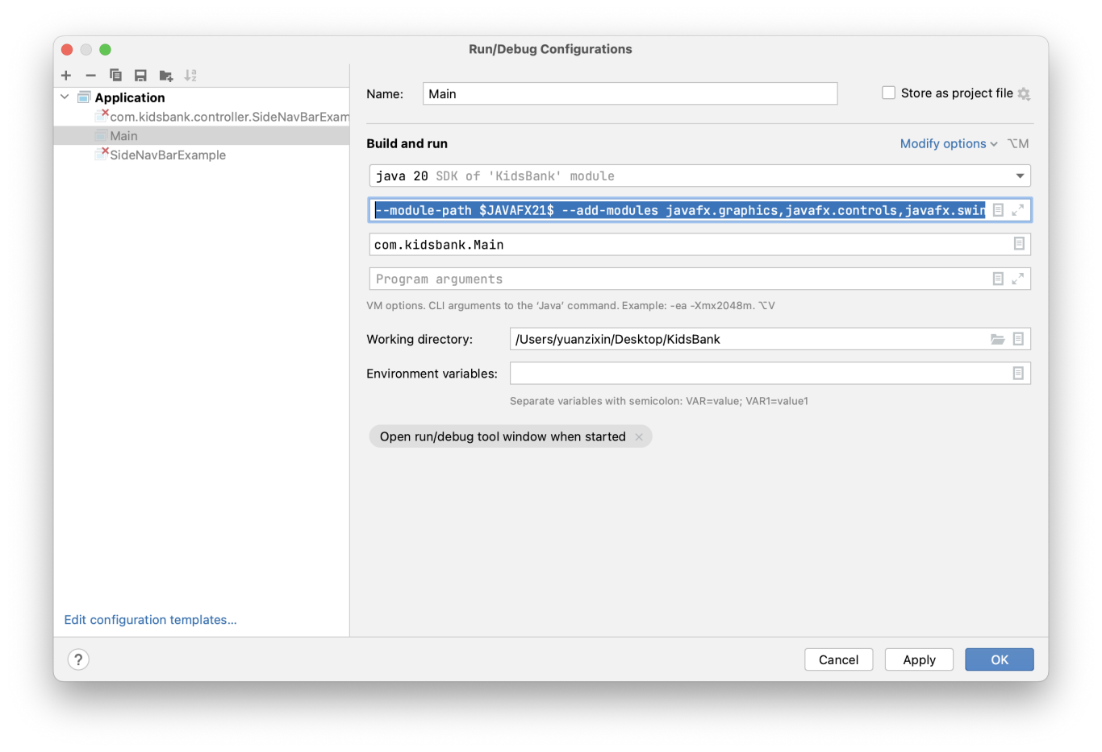

2.2.4 Display changes completed, click Apply>OK

**Test Junit**

3.1 File>Project Structure>Modules>Sources>src>Tests,click Tests

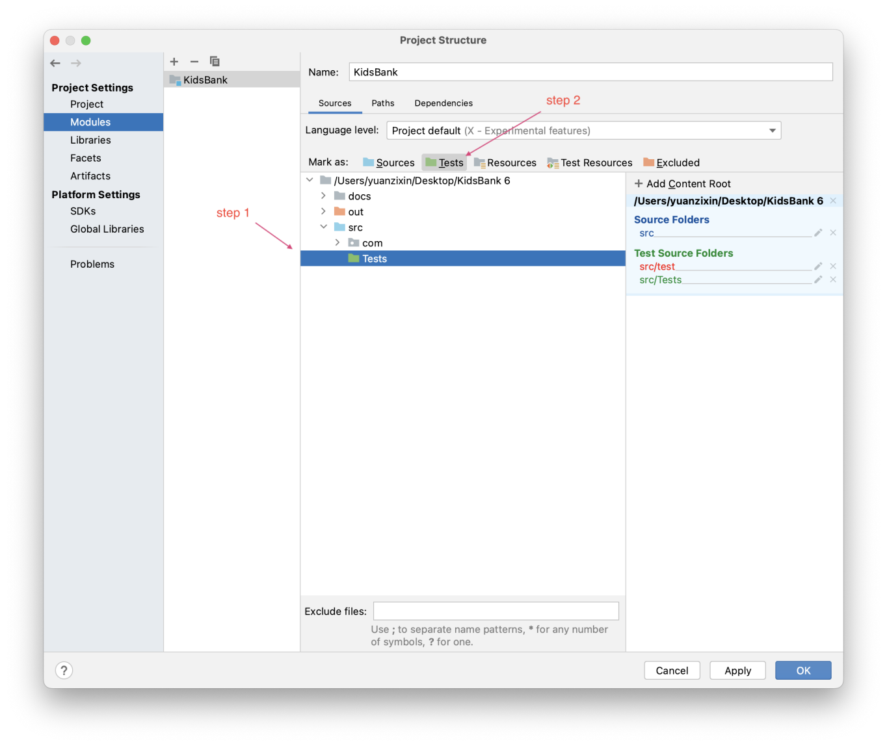

3.2 ClickDependencies> + >JARs or Directories

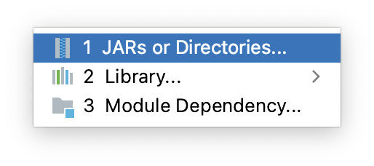

3.3 Select both. jar files in the junit folder of the software package in the pop-up window and click open

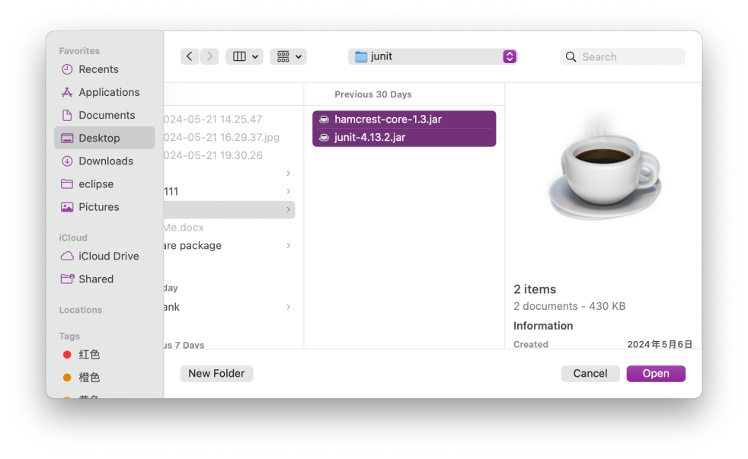

3.4 After two files appear in the Export column, click Apply>OK

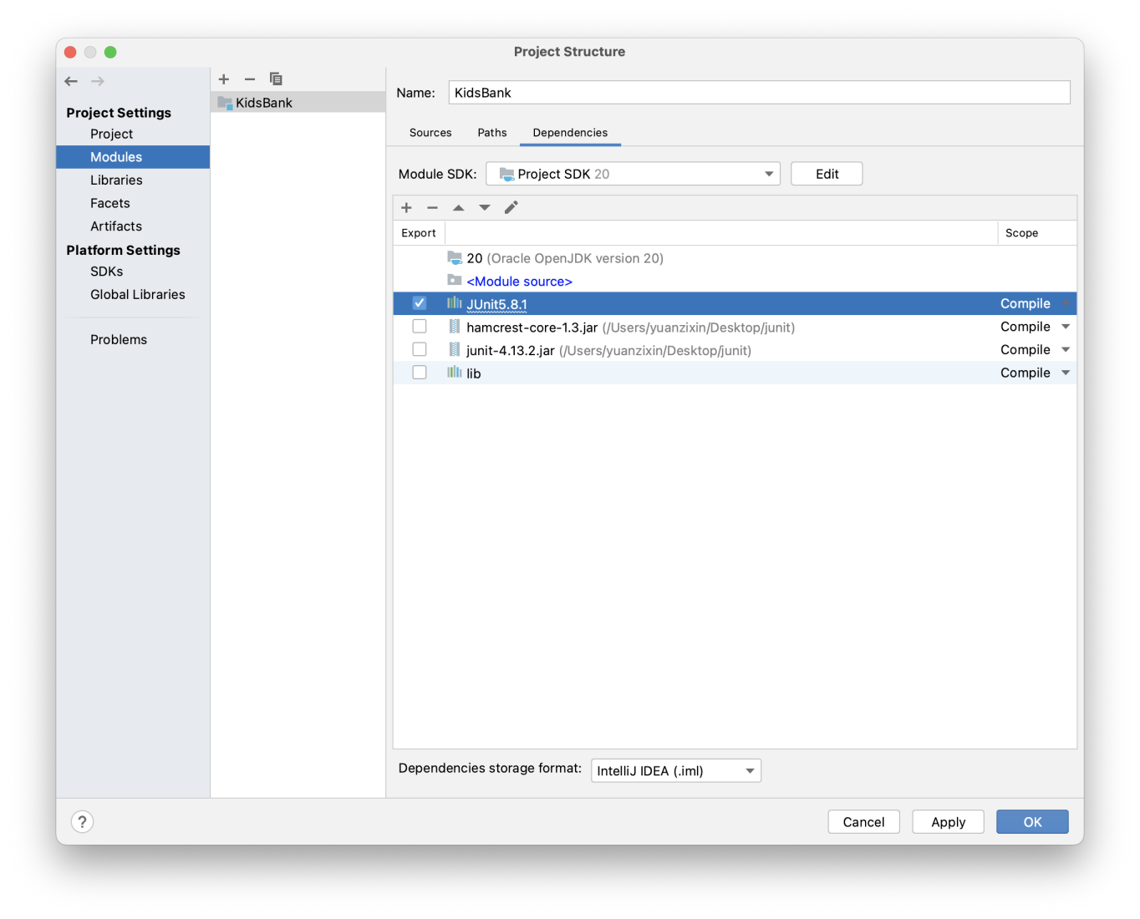

**Download JDK 20**

4.1 Selecting the Download Version

Download address：

<https://www.oracle.com/java/technologies/javase/jdk20-archive-downloads.html>

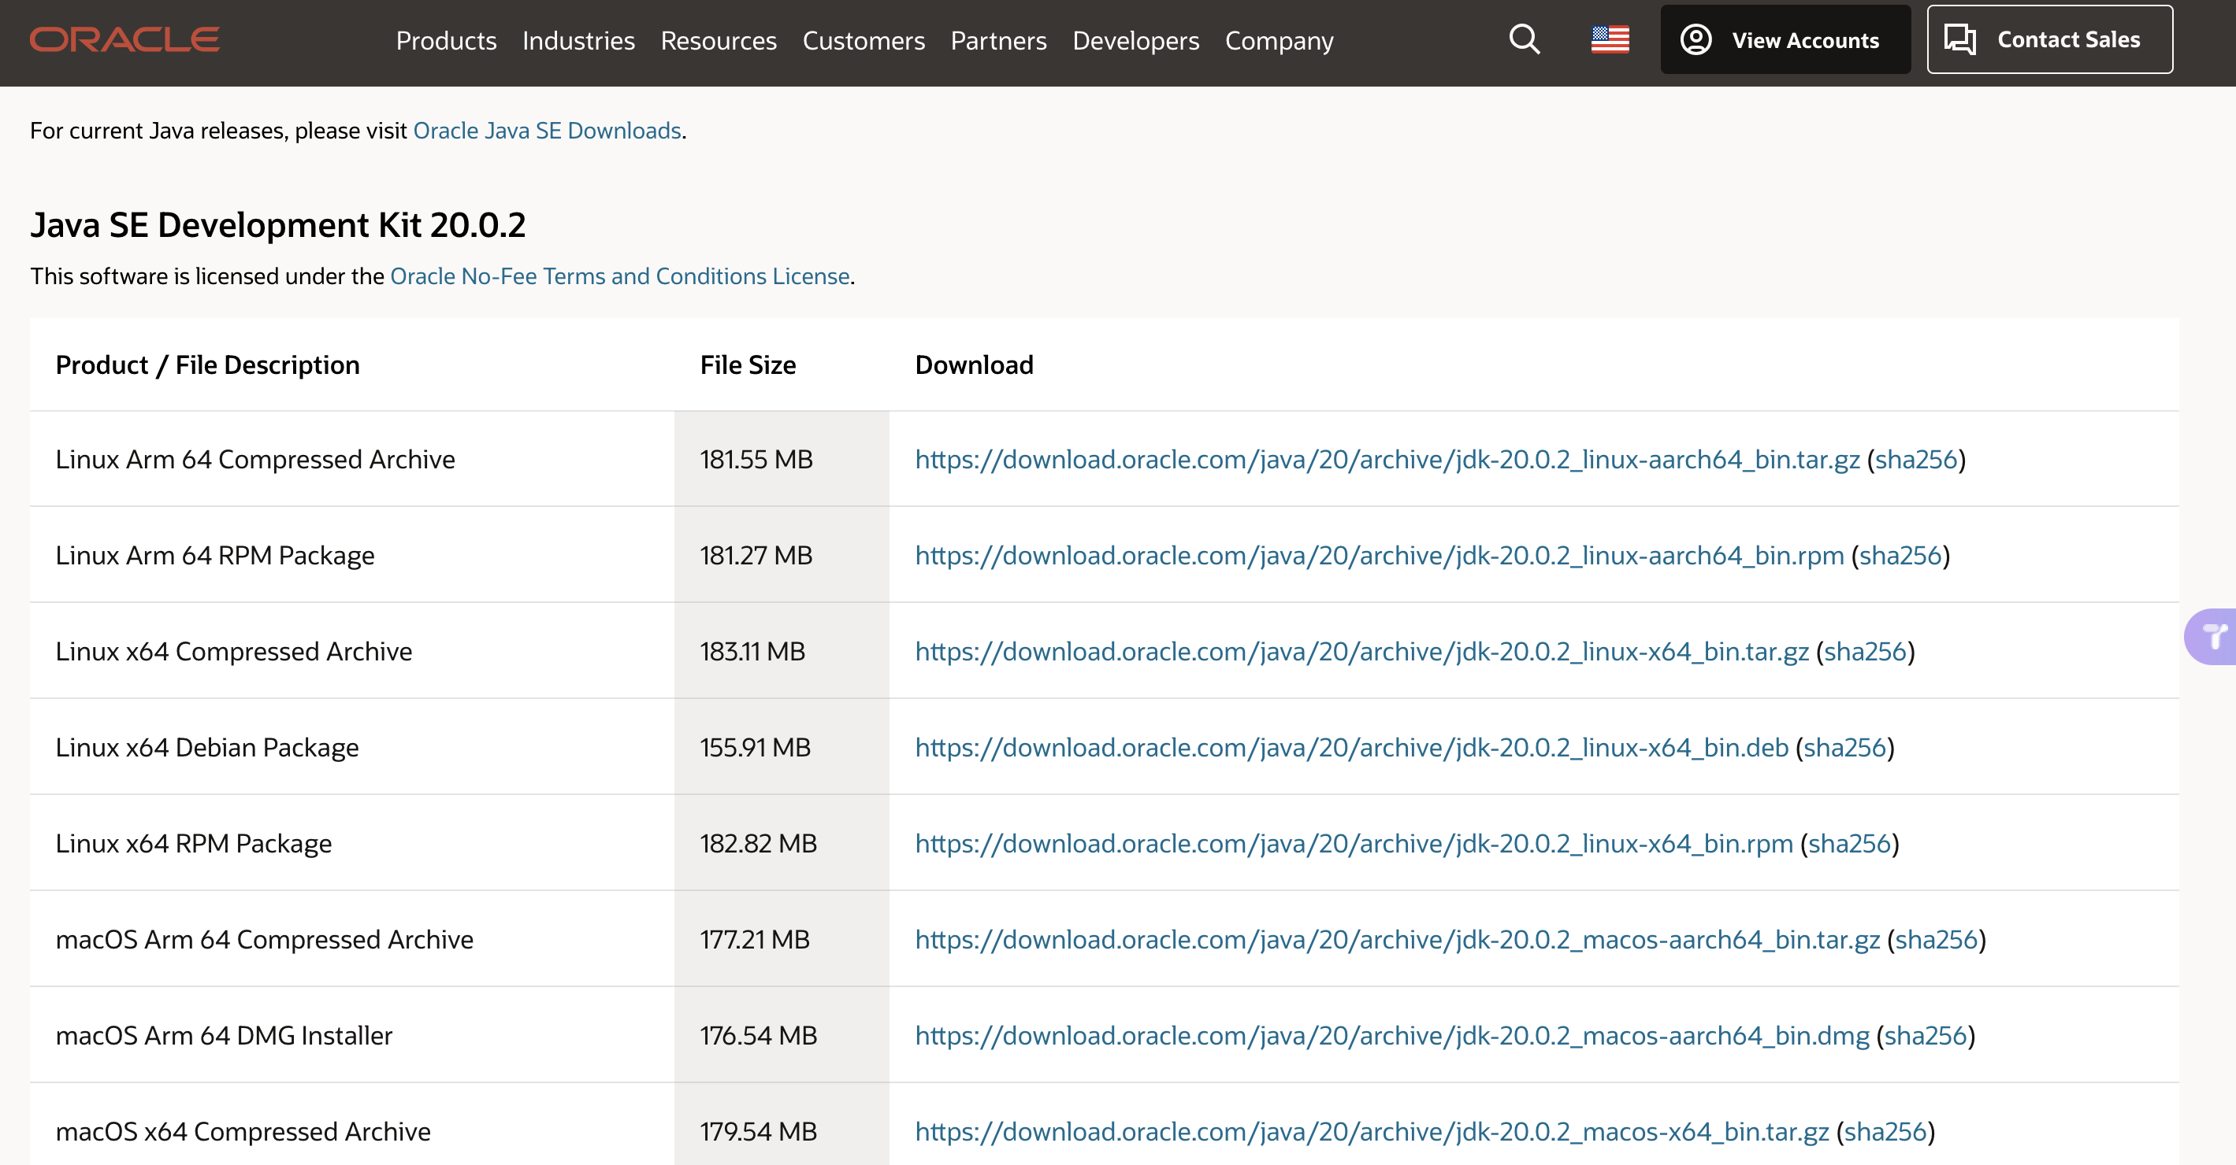

4.2 Configuring JDK 20 in IDEA

File-->Project Structure...-->Platform Settings -->SDKs--> +

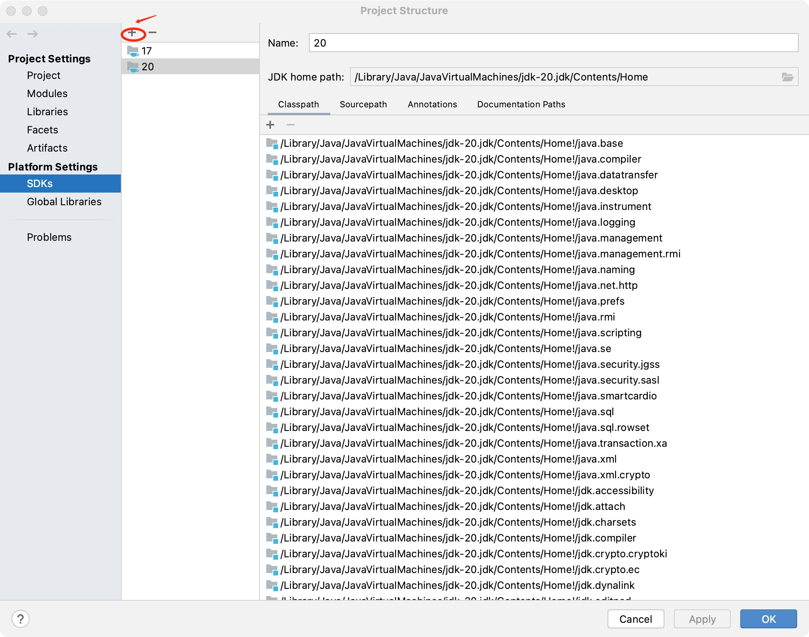

4.3 Select Add JDK... ,and choose the address where yot downlaoded JDK 20 just now.

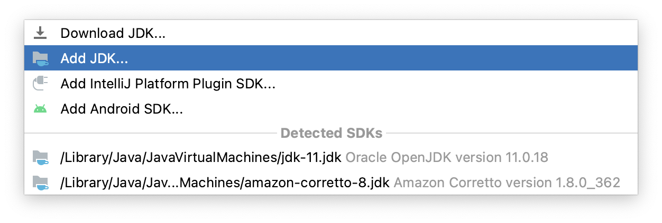

4.4 After successful addition, select Apply>OK

4.5File -->Project Structure... --> Project>SDK

Select JDK20, then select Apply>OK and add successfully

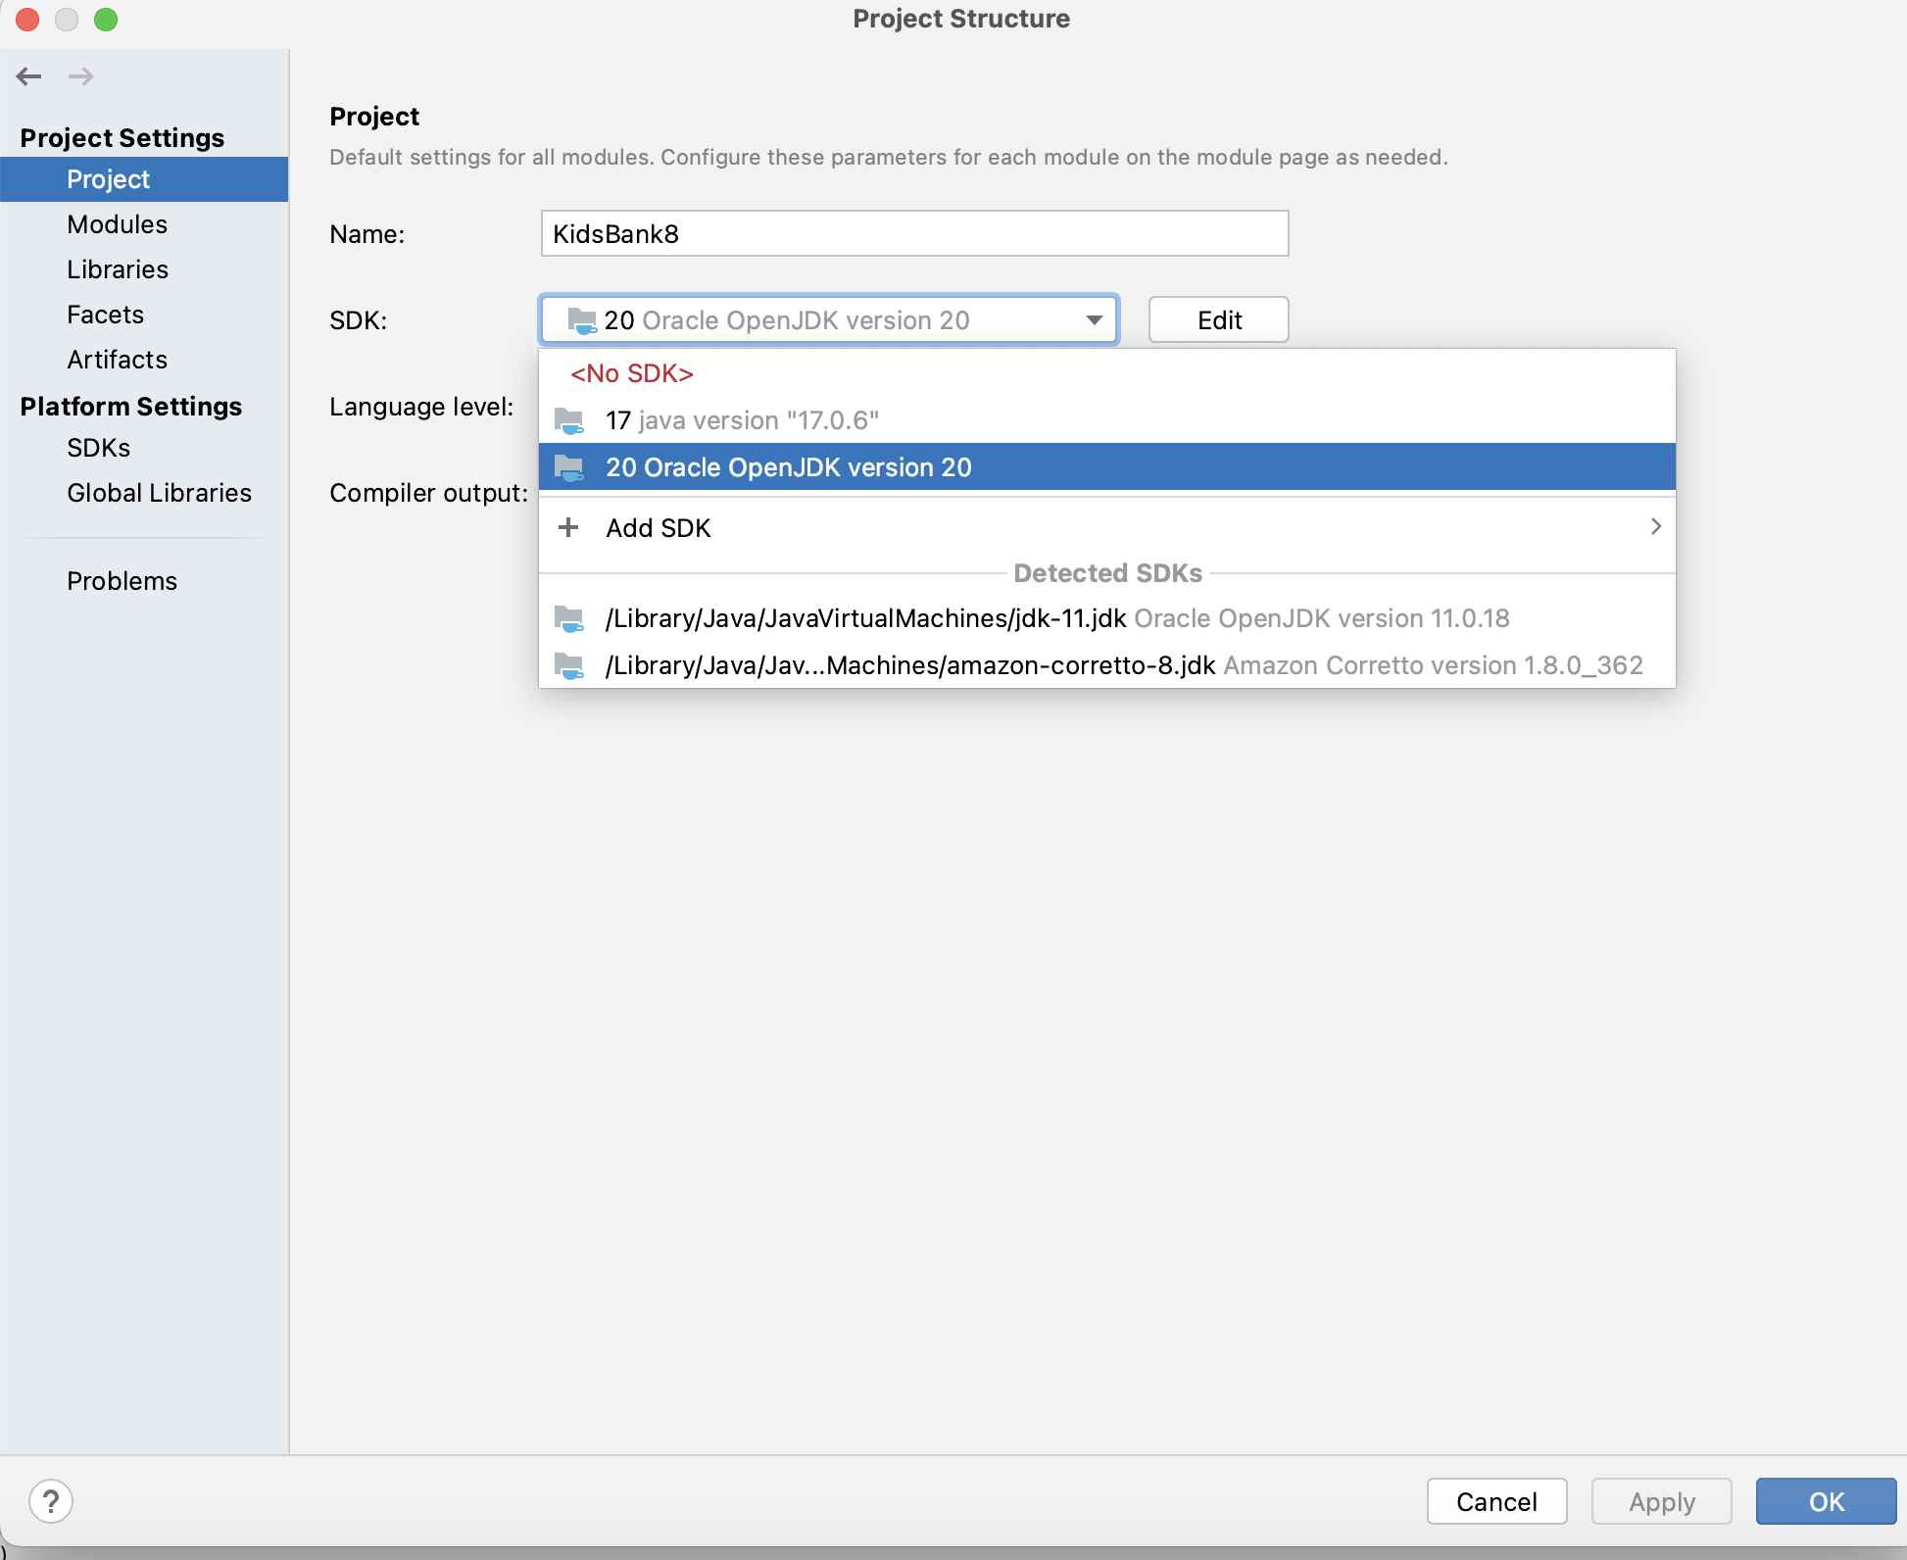

**Intellij IDEA**

Download address:

<https://www.jetbrains.com/idea/download/?section=mac>